

**MATHEMATICS**

**SPECIALIST UNITS 1 & 2**

**Section Two:**

**Calculator-assumed**

| Student Name: _____________________________________ |
| --- |
| Teacher’s Name: _____________________________________ |

**Time allowed for this section**

Reading time before commencing work: ten minutes

Working time for paper: one hundred minutes

**Material required/recommended for this section**

**To be provided by the supervisor**

This Question/Answer booklet

Formula Sheet (retained from Section One)

**To be provided by the candidate**

Standard items:pens (blue/black preferred), pencils (including coloured), sharpener, correction tape/fluid, erasers, ruler, highlighters

Special Items: drawing instruments, templates, notes on two unfolded sheets of A4 paper, and up to three calculators approved for use in the WACE examinations.

**Important note to candidates**

No other items may be taken into the examination room. It is **your** responsibility to ensure that you do not have any unauthorised notes or other items of a non-personal nature in the examination room. If you have any unauthorised material with you, hand it to the supervisor **before** reading any further.

**Structure of this paper**

|  | Number of questions available | Number of questions to be attempted | Working time (minutes) | Marks available | Percentage of exam |
| --- | --- | --- | --- | --- | --- |
| **Section One**  **Calculator—free** | **7** | **7** | **50** | **51** | **35** |
| Section Two  Calculator—assumed | 13 | 13 | 100 | 99 | 65 |
|  | | | |  | 100 |

**Instructions to candidates**

1. The rules for the conduct of Western Australian external examinations are detailed in the

*Year 12 Information Handbook 2017.* Sitting this examination implies that you agree to abide by these rules.

1. Answer the questions according to the following instructions.

**Show all your working clearly.** Your working should be in sufficient detail to allow your

answers to be checked readily and for marks to be awarded for reasoning. Incorrect answers given without supporting reasoning cannot be allocated any marks. For any question or part question worth more than two marks, valid working or justification is required to receive full marks. If you repeat an answer to any question, ensure that you cancel the answer you do not wish to have marked.

It is recommended that you **do not use pencil**, except in diagrams.

1. You must be careful to confine your responses to the specific questions asked and to follow any instructions that are specific to a particular question.
2. Spare pages are included at the end of this booklet. They can be used for planning your responses and/or as additional space if required to continue an answer.

* Planning: If you use the spare pages for planning, indicate this clearly at the top of the page.
* Continuing an answer: If you need to use the space to continue an answer, indicate in the original answer space where the answer is continued, i.e. give the page number. Fill in the number of the question that you are continuing to answer at the top of the page.

1. The Formula Sheet is **not** handed in with your Question/Answer Booklet.

# Section Two: Calculator–assumed 65% (97 marks)

This section has **thirteen (13)** questions. Attempt **all** questions. Write your answers in the spaces

provided.

Spare pages are included at the end of this booklet. They can be used for planning your responses

and/or as additional space if required to continue an answer.

* Planning: If you use the spare pages for planning, indicate this clearly at the top of the page.
* Continuing an answer: If you need to use the space to continue an answer, indicate in the original answer space where the answer is continued, i.e. give the page number. Fill in the number of the question(s) that you are continuing to answer at the top of the page.

Working time: 100 minutes

**Question 8 (5 marks)**

The complex numbers *z* and *w* are such that



(5 marks)

If *wz* = 4, determine the values of *a* and *b* where *a* and *b* are real.

**Question 9 (13 marks)**

(a) Prove that for (4 marks)

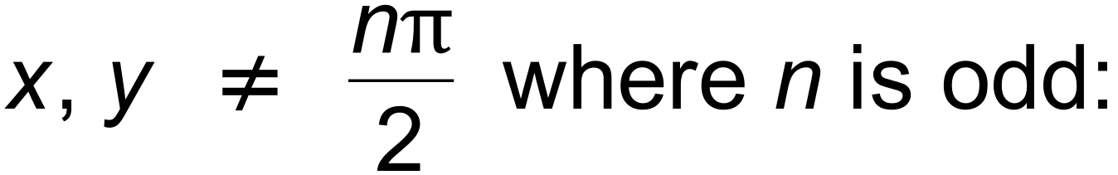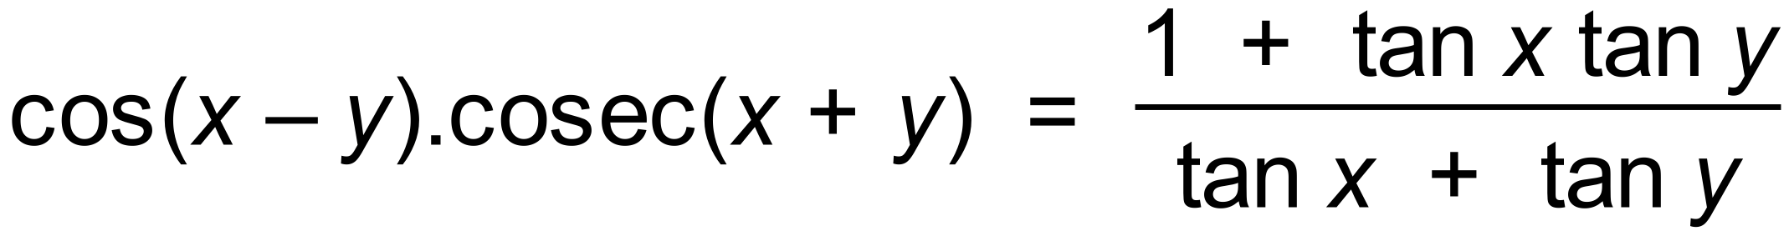

(b) (i) Use vectors to prove that , where *A* and *B* are



angles as shown in the unit circle below.

Hint: Let XOP be angle *A*, XOQ be angle *B*, , then

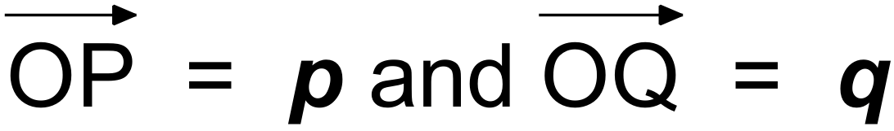

use the dot product. (4 marks)

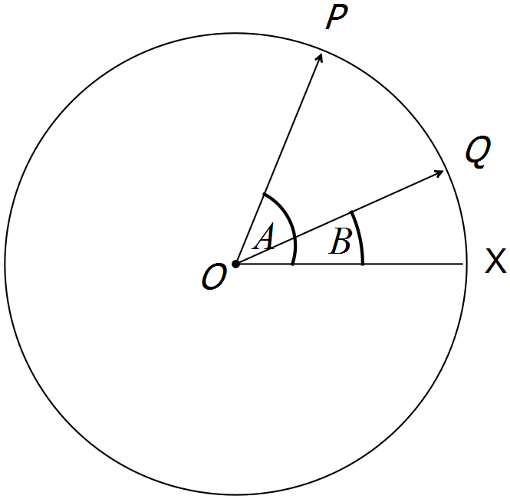

(ii) Let A + *B* = A −(−*B*), and hence prove the identity for cos ( *A* + *B* ). (2 marks)

(iii) Show that cos2 *A* + cos2(120+ *A*) + cos2(120− *A*) = 1.5(3 marks)**Question 10 (7 marks)**



(a) The angle between the unit vectors **a** and **b** is .

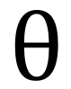

Show that the dot product (3**a** – **b**)(**a** + 3**b**) = 8cos (4 marks)



(b) The position vectors of P and Q are <3,4> and <7,8> respectively.

Determine the length of the projection of onto the *x* axis. (3 marks)

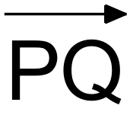

**Question 11 (4 marks)**

A company sells food packs for travellers.

A heath pack consists of 5 bottles of orange concentrate and 1 bottle of banana concentrate.

A diet pack consists of 2 bottles of orange concentrate and 3 bottles of banana concentrate.

Health packs cost $19 and Diet packs cost $18.

(a) Use the given information to form a system of equations to determine the cost of

each type of bottled concentrate. (1 mark)

(b) Use an inverse matrix method to solve the system. Show all steps in the solution.

(3 marks)

**Question 12 (8 marks)**

A helicopter wishes to travel due east to his destination 8 km away. However, there is a wind blowing from the north at 30 km/hr.

The helicopter can travel at 60 km/hr in still conditions.

(a) Use the axes below to draw a diagram of the situation. (2 marks)

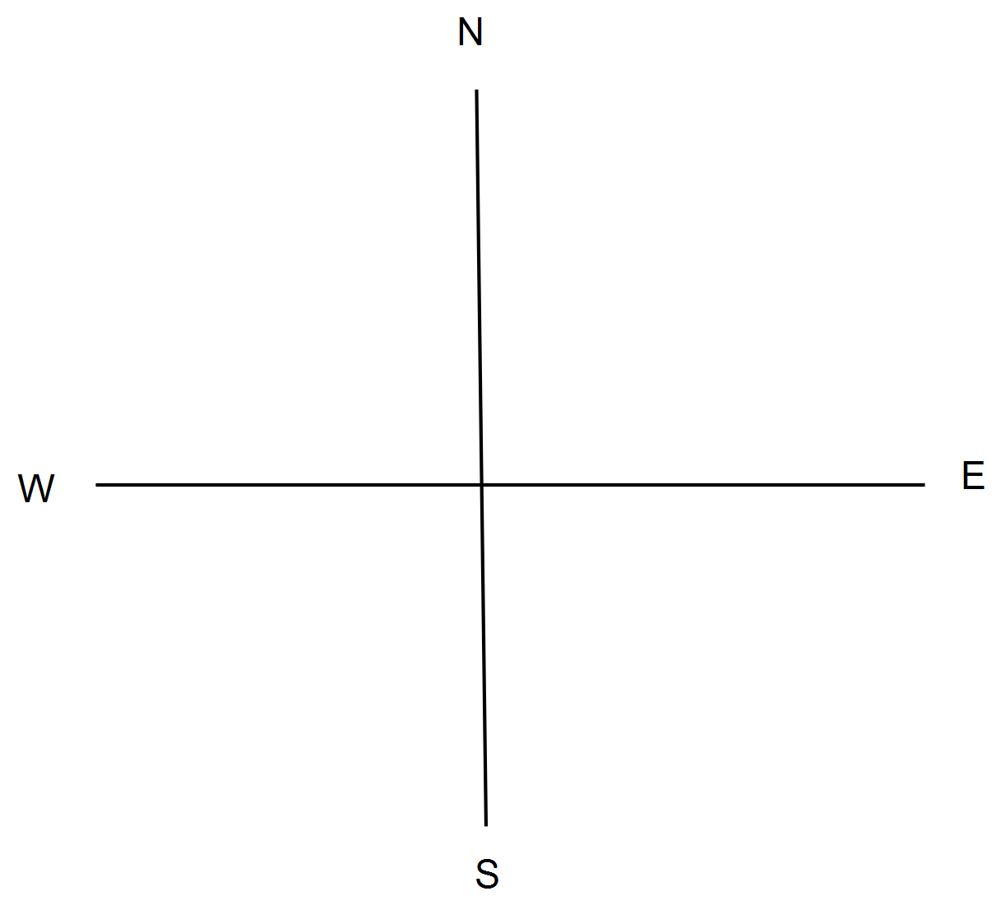

(b) Determine the direction in which the helicopter should head in order to achieve the Easterly result. (4 marks)

(c) How many minutes will it take the helicopter to reach his destination? (2 marks)

**Question 13 (13 marks)**

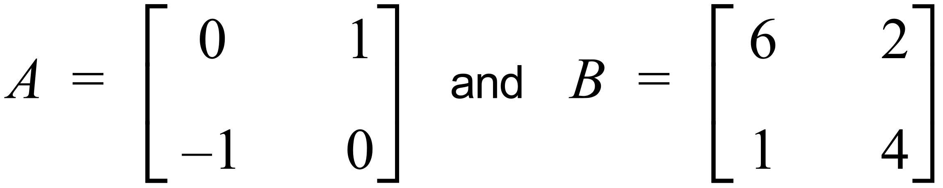

(a) Determine:

(i) *A*2, and describe it as a transformation. (2 marks)

(ii) *A*3, and describe it as a transformation. (2 marks)

(b) If *PB* = 6[ *B* − 2*A* ], determine *P*. (3 marks)

***Question 13 continued.***

(c) Find the image of the point (2, 3) under the transformation that is equivalent

to A followed by B. (2 marks)

(d) If B was applied to a square of side length 5 units, what would be the area of

the resultant figure? (2 marks)

(e) If a singular matrix was applied to the square in (d), what would be the shape of

the resultant figure? Give a reason. (2 marks)

**Question 14 (6 marks)**

Two vectors ***x*** and ***y*** are such that ***x*** = 2**i** + 3**j** and ***y*** = *m***i** − 5**j**.

Determine *m* if:

(a) 3***x*** – ***y*** = 8**i** +14**j** (2 marks)

(b) ***x*** and ***y*** are parallel. (2 marks)

(c) ***x*** and ***y*** are perpendicular. (2 marks)

**Question 15(7 marks)**

Consider the function .



(a) Express *g* (*A*) in the form (4 marks)



Hence, or otherwise,

(b) determine:

(i) the exact minimum value of *g* (*A*) over its domain. (1 mark)

(ii) the smallest positive value of *A* when this minimum happens. (2 marks)

**Question 16 (8 marks)**

A theorem states: “The angle at the centre of a circle is double that of the angle at the circumference,

subtended on the same arc”.

(a) Determine the size of the angle subtended at the circumference of a circle by a chord

equal in length to the radius.

(2 marks)

(b) (i) ABCD is a cyclic quadrilateral. AB and CD are each equal in length to the radius.

AC and BD intersect at E. Determine the size of angle AEB. (3 marks)

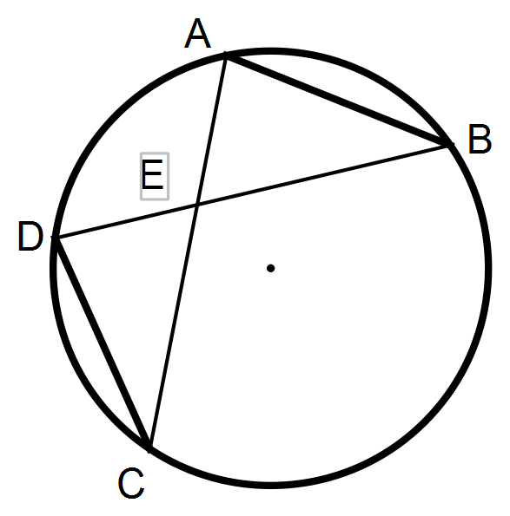

(ii) Prove that E cannot be the centre of the circle. (3 marks)

**Question 17 (8 marks)**

(a) Consider the complex number given in the Argand plane below.

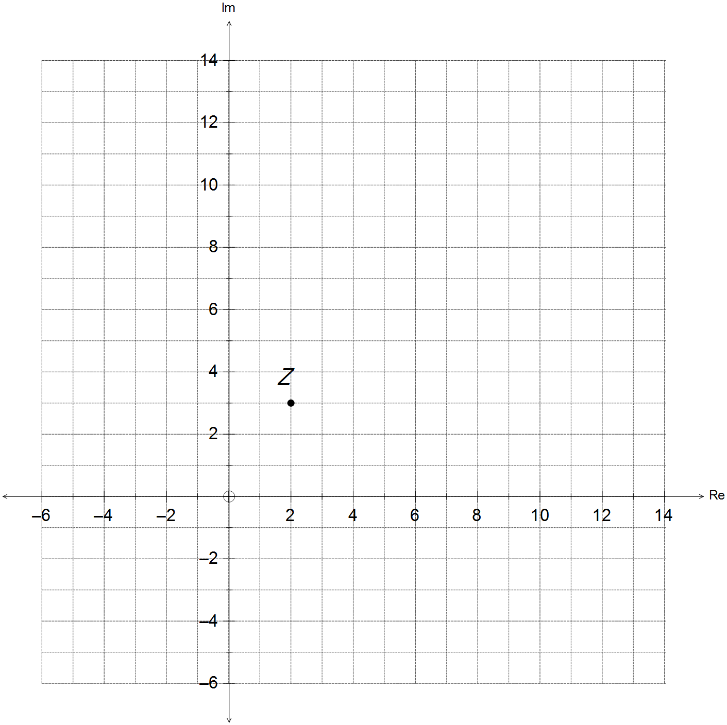

Sketch each of the following on the same diagram.

(i) (2 marks)

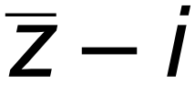

(ii) (2 marks)



(iii) (2 marks)

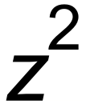

(iv) (2 marks)

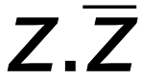

**Question 18 (7 marks)**

The height, *h* metres, of a rider above the ground on a large Ferris wheel, at time *t* minutes after it starts moving can be determined by the equation .

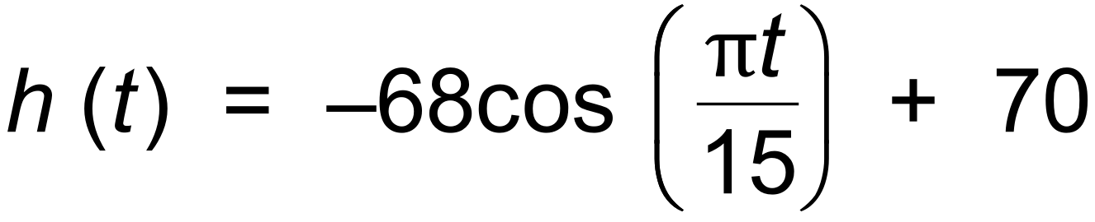

(a) At what height do riders get into the seats on the wheel? (1 mark)

(b) How long does the wheel take for one revolution? (2 marks)

(c) What is the maximum height reached by a rider on the wheel? (1 mark)

(d) A rider completes 1 revolution on the wheel.

For how many minutes is the rider more than 100 metres above ground? (3 marks)

**Question 19 (6 marks)**

(a) Given the non−singular square matrices A and B, show why:

(A + B)2 ≠ A2 + 2AB + B2. (2 marks)

(b) A, B and C are non−singular square matrices such that AB = BC.

Show A3 = B C3 B−1. (4 marks)

**Question 20 (7 marks)**

The vertices of a square are O, A, B and C where O is the origin.

= 4**i**, and = 4**j**.

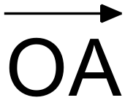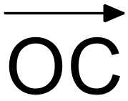

(a) Write in component form. (2 marks)

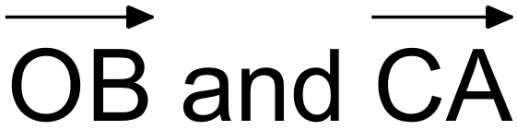

(b) Prove that the diagonals of the square are perpendicular to each other. (2 marks)

(c) Prove that the diagonals of the square bisect each other. (3 marks)

**End of questions**

**Additional working space**

Question number(s): ……………………

**Additional working space**

Question number(s): ……………………

**Additional working space**

Question number(s): ……………………